Introduction:
These instructions are to be used by handling staff working outside EU with shipments going into EU.
European Union has issued new requirements for ALL cargo and mail being sent from outside EU (“3rd countries”) into EU. EU customs and Danish customs
Standards and guidelines:
Do NOT forward any Mail - if they are missing the “OK” from EU (“AR flag”)

Ground Handling Agents (GHAs) have been given:
- Updated Handling Requirements Air Mail

Definitions:
ICS2 introduces more efficient and effective EU customs security and safety capabilities that will:

- Increase protection of EU citizens and the internal market against security and safety threats;
- Allow EU Customs authorities to better identify high-risk consignments and intervene at the most appropriate point in supply chain;
- Support proportionate, targeted customs measures at the external borders in crisis response scenarios;
- Facilitate cross-border clearance for the legitimate trade;
- Simplify the exchange of information between Economic Operators (EOs) and EU Customs Authorities

Description / Explanation:
Air Mail: Postal Operator communicate with SAS Cargo via Cardits/Receptacle.
The cardit/receptacle will carry an “AR” flag (message from EU).

- If Cardit/Receptacle is OK – the information in the “total” view (se screenshot below) will be blank.

- If the message is NOT OK it will be:
“Applicable regulations not satisfied”.
This item must be set aside”: HOLD and contact SAS Cargo local sales office for new disposition
“HOW TO”:
Air Mail – check in VMAIL system
VMAIL link: Account Login: SAS (SK) (velocity-mail.com)
Start in “STATION” - and choose the station in question (here e.g. EWR) from drop down list
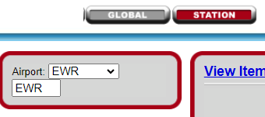
It opens at “NESTS”/ nest at station
It will show the air mail planned for this station.
Use drop-down to choose the destination station in question: (here e.g. CPH)
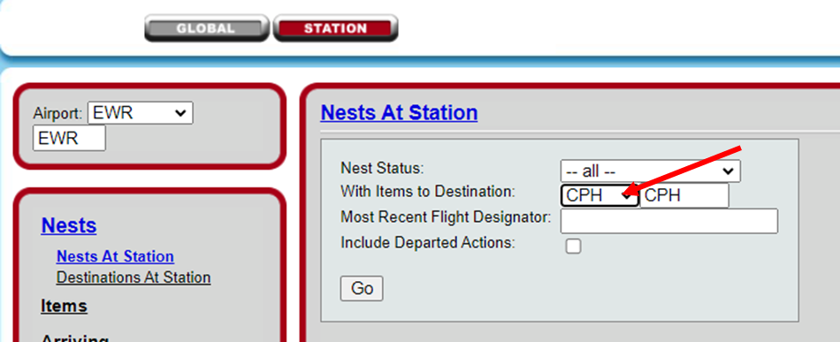
See “Notes” for ICS2 OK or not OK:
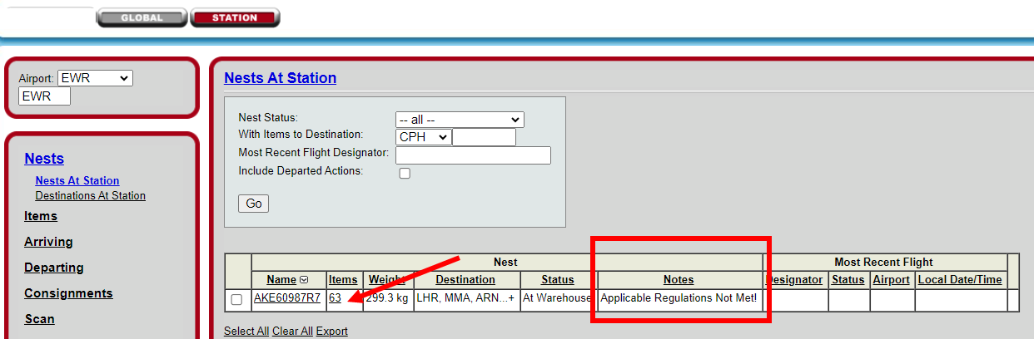
Blank lines in “Notes” = OK
“Applicable Regulations Not Met!” means it is NOT OK to forward.
Click the underlined number of “items”
Go the drop-down box on the right and choose “By Consignment”
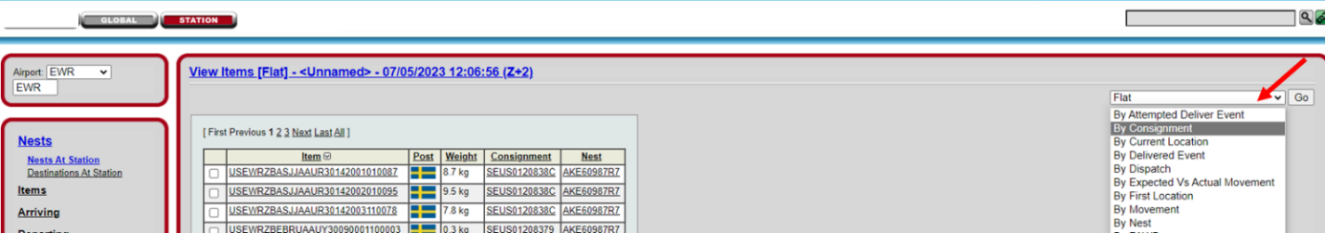

The view “by Consignment” shows which cardits/consignments that are OK or NOT OK
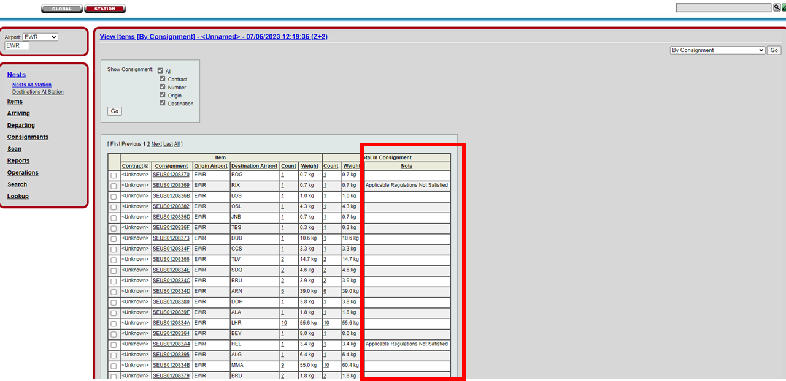
Blank lines in “Note” = OK
“Applicable Regulations Not Met!” means it is NOT OK to forward.
- If the consignment is not in SAS Cargo custody yet – contact Postal Operator and tell them to not send this bag
- If the bag is tendered to GHA – please tell the postal Operator to take it back to Post w/h as it is not OK to fly
- If the bag is transfer – GHA must put “on hold” (aside) and contact SAS Cargo Sales office/cargobooking for new disposition
You can always insert one cardit/receptacle number and search for that specifically:
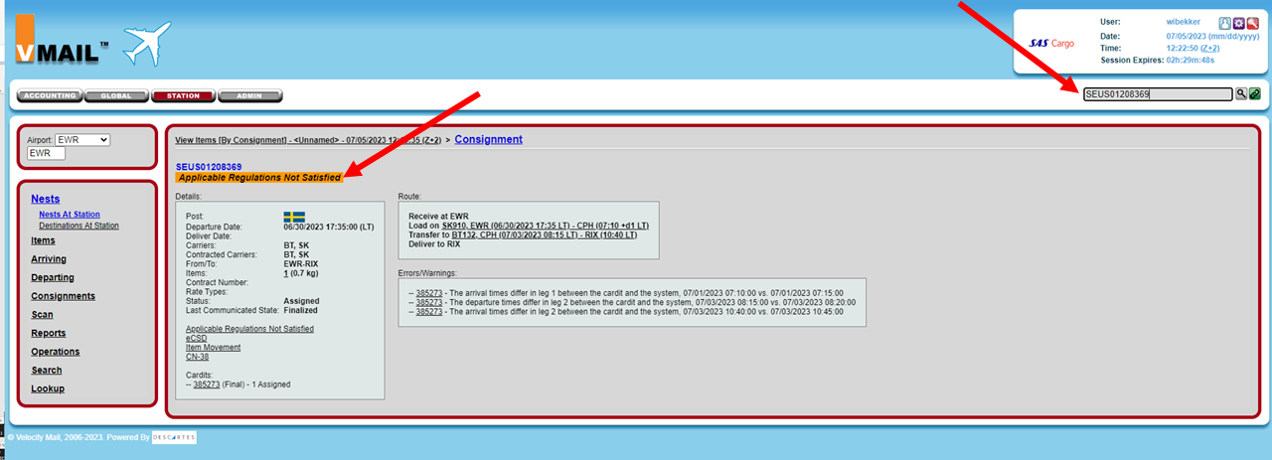

Descartes Support desk:
To be used if technical problems with ICS2 system or VMAIL.
Support Portal: https://servicedesk.descartes.com
24 Hour Service Desk
Phone:
1.877.786.9339 (North America)
+800.7866.3390 (Outside of North America)
When prompted, say “VMAIL”

Document info:
Author: | Approved by: | Effective date:
Wibekke Risan CPHFZ | Lone Riise HQSS | 01JUN2023
Document review date: | Document review by: | Department:
05JUL2023 | Wibekke Risan and Lone Riise | CPHFZ/HQSS
SCM Document: | sascargo.com: | Live Document:
Updated by HQSS | Updated by HQSS | Updated by HQSS

