E195

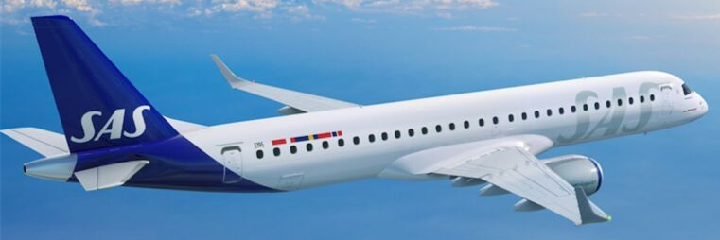

Compartments:

Maximum weights and volumes:

This table shows the maximum weights and volumes per compartment 1, 2, 3 and 4:
Note: NA indicates that volume figure is not given.

 | Compartment
 | 1 | 2 | 3 | 4
Weight (kg) | 710 | 912 | 851 | 550
Combined weight (kg) | 1622 |  | 1401
Area load (kg/m²) | 488 | 488 | 488 | 488
Volume (m³) | 11,04 |  | 11,2

Maximum dimension tables:

Forward hold (1 + 2)

These tables show the maximum dimensions of cargo items in forward hold.

The dimensions are approximate values and refer to rectangular packages.
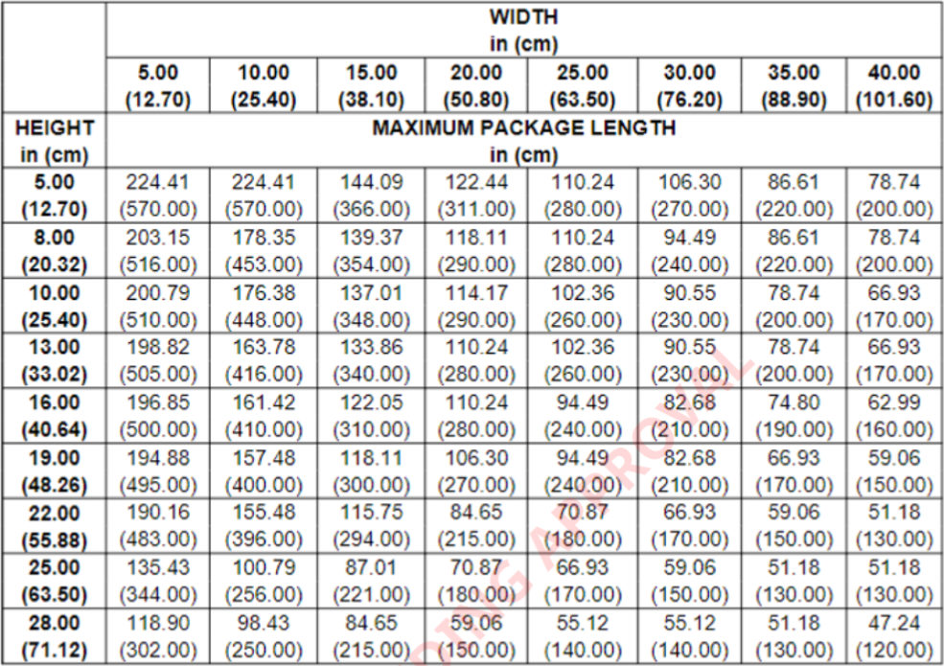

Aft hold (3 + 4)
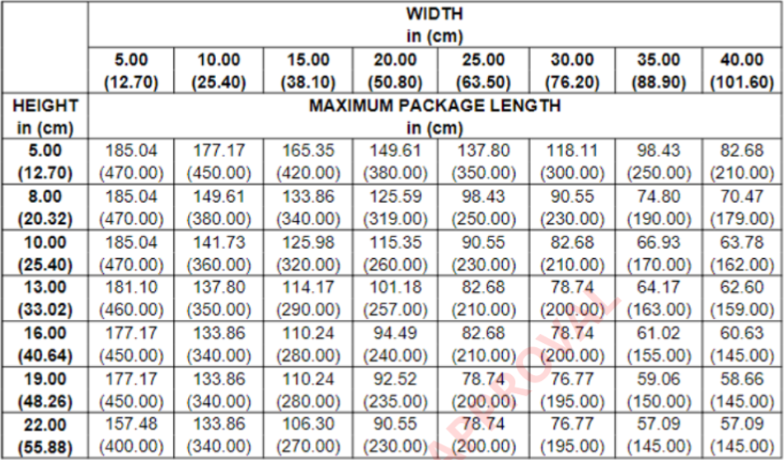
Air conditioning system:
The lower compartments are incorporated in the same pressure system as the passenger cabin.
No temperature control is available. Both holds are indirectly heated by the passenger cabin.
Restrictions
Dangerous Goods
Dry Ice: Maximum amount in Compartment.
Maximum amount of ICE per compartment
Combined weight
A/C version | Maximum amount  of ICE per A/C | Forward hold | Aft hold
E195 | 50 | 25 | 25
Note: Not to be loaded in the same hold as Live Animals (AVI). (AVF-Aquatics and live fish can be loaded in the same hold as ICE).
For E195 compartments 11-22 is the same hold, therefore AVI cannot be loaded in Cpt 22 if there is ICE in Cpt 12 and vice versa. Compartments 31-42 is also the same hold, therefore AVI cannot be loaded in Cpt 42 if there is ICE in Cpt 31 and vice versa..
Radioactive Materials: Maximum Transport Index (TI)
 |  |  | Max TI pr. Compartment
A/C version | Max TI pr. aircraft | Max TI pr. package  (or Group of packages) | 11-13 | 21-22 | 31-32 | 41-42
E195 | 9 | See note and table below | 3 | 3 | 3 | 0
Note 1: The maximum allowed TI per package (or group of packages), is depending on the height of the package (or group of packages).
Radioactive Materials: Maximum Package/Group Height and Separation Distance
The below table shows:
    - The maximum allowed height per package (or group of packages).
    - The minimum separation distance (horizontally) between packages (or groups of packages).
Note: Use the column for Minimum separation distance when:
- the package/group height, or
- the Transport Index (TI)
exceeds the permitted values for grouping packages together.
Transport Index  (TI) per package  (or group of  packages) | Max. height per  package (or  group of  packages) (cm) | Min. separetion  distance  horizontally (cm) | Category
0.0 | No restriction | No restriction | I – White (RRW)
0.0–1.0 | 65 | 100 | II – Yellow (RRY)
1.1–2.0 | 45 | 150 | III – Yellow (RRY)
2.1–3.0 | 27 | 210 | III – Yellow (RRY)
Note: For the separation of packages (or groups of packages with different Transport Indices (TI), the minimum separation distance required for the package (or group of packages) with the higher transport index must be applied.
Heavy
Heavy items (HEA) are not allowed on this aircraft type, due to the low floor panel capacity and the low capacity of the tie down points. The maximum weight per single item is 80kg
The aircraft has no dedicated tie-down points. If individual items need to be tied down, the cargo net attachment points shall be used.
Always check SIRIUS for current restrictions on origin, destination and possible embargoes.
Human Remains
No aircraft restrictions other than maximum dimensions, area load and maximum load in hold, but always check SIRIUS for current restrictions on origin, destination and possible embargoes.
Live Animals

SAS has two animal codes that differ from the IATA standard.

AVC – Crustaceans
AVF - Aquatics and live fish

Note: Crustaceans, aquatics and live fish can be secured by volumetrically filling the compartment. AVC and AVF can be loaded together with EAT, AVF can be loaded together with ICE.

Most live animal shipments must be treated as wet cargo. Therefore, plastic sheeting or tarpaulin must be placed under live animal containers in order to avoid soilage of aircraft holds, ULD’s and other load.

Isolation from Cold Transfer Beneath Animal Cages
Loaded animal cages need to be insulated from cold transfer, as the aircraft does not have heated floors in the cargo compartments. Insulation can be made by various methods, such as: Spreader boards under the cage; insulating material, blankets etc.
Note: If the insulating material also can absorb fluids, the LAR requirement to have plastic under the boxes or cages can be ignored.

 |  | Maximum qty in compartment (kg)
Group | Animal, Example | Forward | Aft
1 | Tropical fish, fish | No limit | No limit
2 | Shrimps, reptiles, snakes, crabs, frogs, oysters | No limit | No limit
3 | Cats, dogs, other pets | 0
4 | Other animals | 0 | 0

Live Human Organs

Live Human Organs (LHO) shall be loaded close to the cargo door.
Ground Operations, in coordination with Flight Operations and Security, may grant an exception to stow LHO in cabin.
Restriction: Separate from Radioactive materials by at least 0,5 meters.
Perishables
No aircraft restrictions other than maximum dimensions, area load and maximum load in hold, but always check SIRIUS for current restrictions on origin, destination and possible embargoes.
Sensitive
No aircraft restrictions other than maximum dimensions, area load and maximum load in hold, but always check SIRIUS for current restrictions on origin, destination and possible embargoes.
Valuable
No aircraft restrictions other than maximum dimensions, area load and maximum load in hold, but always check SIRIUS for current restrictions on origin, destination and possible embargoes.
Vulnerable
No aircraft restrictions other than maximum dimensions, area load and maximum load in hold, but always check SIRIUS for current restrictions on origin, destination and possible embargoes.

Document info:
Author: | Approved by: | Effective date:
Michael Beck, CPHFD | Michael Beck, CPHFD | 10NOV2022
Document review date: | Document review by: | Department:
10NOV2022 | Michael Beck, CPHFD | CPHFD
SCM Document: | sascargo.com: | Live Document:
Yes | Yes | Yes

