B737-800
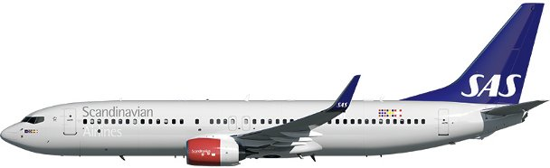

Compartments
Sliding Carpet:
In an effort to improve the working environment of the loading personnel and to facilitate the loading of baggage, cargo and mail, a sliding carpet loading system is installed in compartments according to the table below.
 | Compartment
Aircraft type | 1 | 2 | 3 | 4
B737-800 | - | - | Installed | -
No HEA, AVI or any dangerous goods may be loaded in a compartment with sliding carpet.
To fulfil requirements for items weighing up to 149 kg that need to be secured, any one-carpet area must be loaded volumetrically full.
Maximum weights and volumes:
This table shows the maximum weights and volumes per compartment 1, 2, 3 and 4:
 | Compartment
With sliding carpet | 1 | 2 | 3 | 4
Weight (kg) | 888 | 2670 | 3531 | 667
Combined weight (kg) | 3358 |  | 4198
Area load (kg/m2) | 732 | 732 | 732 | 732
Volume (m3) | 4,39 | 14,64 | 19,00 | 3,85

 | Compartment
Without sliding carpet | 1 | 2 | 3 | 4
Weight (kg) | 888 | 2670 | 3777 | 667
Combined weight (kg) | 3558 |  | 4507
Area load (kg/m2) | 732 | 732 | 732 | 732
Volume (m3) | 4,39 | 14,64 | 20,75 | 3,85
Maximum dimension tables:
Compartment 1 + 2
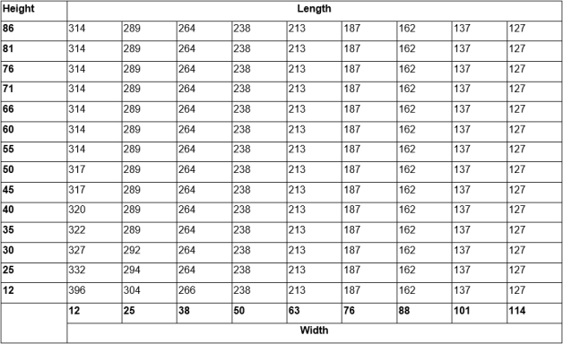
Compartment 3 + 4
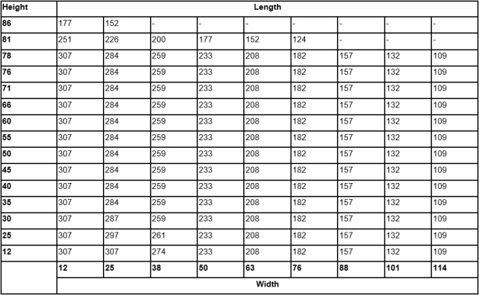
Air conditioning system:
Compartment | Description
1 and 2 | The temperature inside the compartments is thermostatically controlled for heating only.  Typical in-flight temperatures vary between 15 and 30 degrees centigrade (C°).  Both compartments are incorporated in the pressurization system, but the ventilation is very poor.
3 and 4 | The compartments usually maintain a temperature of 0 degree centigrade (C°) or slightly higher.  Both compartments are incorporated in the pressurization system, but the ventilation is very poor.
Restrictions
Dangerous Goods
Dry Ice: Maximum amount in Compartment.
 |  | Maximum amount of ICE per compartment
A/C version | Maximum amount  of ICE per A/C | 1 | 2 | 3 | 4
B737-800 | 400 | 400 | 400 | 400 | 400
Note: Not to be loaded in the same hold as Live Animals (AVI).
Radioactive Materials: Maximum Transport Index (TI)
 |  |  | Max TI pr. Compartment
A/C version | Max TI pr. aircraft | Max TI pr. package  (or Group of packages) | 1 | 2 | 3 | 4
B737-800 | 10 | See note below | 2 | 4 | 4 | 0
Note: The maximum allowed TI per package (or group of packages), is depending on the height of the package (or group of packages).
Radioactive Materials: Maximum Package/Group Height and Separation Distance
The below table shows:
- The maximum allowed height per package (or group of packages).
- The minimum separation distance (horizontally) between packages (or groups of packages).
Note: Use the column for Minimum separation distance when:
- the package/group height, or
- the Transport Index (TI)
exceeds the permitted values for grouping packages together.
Transport Index  (TI) per package  (or group of  packages) | Max. height per  package (or  group of  packages) (cm) | Min. separetion  distance  horizontally (cm) | Category
0.0 | No restriction | No restriction | I – White (RRW)
0.0–1.0 | 77 | 100 | II – Yellow (RRY)
1.1–2.0 | 57 | 150 | III – Yellow (RRY)
2.1–3.0 | 37 | 210 | III – Yellow (RRY)
More than 3 | Not allowed | Not allowed | III – Yellow (RRY)
Heavy
The maximum weight for HEA onboard a B737 is 400 kg due to lashing capacities. The below table is a function of the number of tie down points and running load limit.
Max. Weight per HEA in Compartments
Aircraft type | Cpt 1 | Cpt 2 | Cpt 3 | Cpt 4
B737-800 | 360 kg | 400 kg | Embargo | Embargo
Human Remains
No aircraft restrictions other than maximum dimensions, area load and maximum load in hold, but always check SIRIUS for current restrictions on origin, destination and possible embargoes.
Live Animals
SAS has two animal codes that differ from the IATA standard.

AVC – Crustaceans
AVF - Aquatics and live fish

Note: Crustaceans, aquatics and live fish can be secured by volumetrically filling the compartment. AVC and AVF can be loaded together with EAT, AVF can be loaded together with ICE.

Most live animal shipments must be treated as wet cargo. Therefore, plastic sheeting or tarpaulin must be placed under live animal containers in order to avoid soilage of aircraft holds, ULD’s and other load

Isolation from Cold Transfer Beneath Animal Cages
Loaded animal cages need to be insulated from cold transfer, as the aircraft does not have heated floors in the cargo compartments. Insulation can be made by various methods, such as: Spreader boards under the cage; insulating material, blankets etc.
Note: If the insulating material also can absorb fluids, the LAR requirement to have plastic under the boxes or cages can be ignored.

 |  | Maximum qty in compartment (kg)
Group | Animal, Example | 1 + 2 | 3 + 4
1 | Tropical fish, fish | No limit | No limit
2 | Shrimps, reptiles, snakes, crabs, frogs, oysters | No limit | No limit
3 | Cats, dogs, other pets | See note ¹
4 | Other animals | 275 | n/a

Note [1]

Number of Animal Cages | Flight Time:  Less than 2 hours | Flight Time:  2 hours and Above
1 | Plan the crate in CPT 1. no other load allowed in CPT 1. | Plan the crate in CPT 1. no other load allowed in CPT 1.
2 or more | Plan one in CPT 1, no other load allowed in CPT 1.  Plan the second crate in CPT 2* or 4**. | Plan one in CPT 1, no other load allowed in CPT 1.  Plan the second crate in CPT 2*.

* Any other load in CPT 2 needs to be tied down.
** Compartment 4 may only be used, if no other option is available. CPT 4 shall in that case only contain the animal crate.

Live Human Organs
Live Human Organs (LHO) shall be loaded in compartment 2, as close as possible to the cargo door.
STOOG, in coordination with STOOG and STOG3, may grant an exception to stow LHO in cabin.
Restriction: Separate from Radioactive materials by at least 0,5 meters.
Perishables
No aircraft restrictions other than maximum dimensions, area load and maximum load in hold, but always check SIRIUS for current restrictions on origin, destination and possible embargoes.
Sensitive
No aircraft restrictions other than maximum dimensions, area load and maximum load in hold, but always check SIRIUS for current restrictions on origin, destination and possible embargoes.
Valuable
No aircraft restrictions other than maximum dimensions, area load and maximum load in hold, but always check SIRIUS for current restrictions on origin, destination and possible embargoes.
Vulnerable
No aircraft restrictions other than maximum dimensions, area load and maximum load in hold, but always check SIRIUS for current restrictions on origin, destination and possible embargoes.

Document info:
Author: | Approved by: | Effective date:
Michael Beck, CPHFD | Michael Beck, CPHFD | 03APR2017
Document review date: | Document review by: | Department:
27MAR2023 | Michael Beck, CPHFD | CPHFD
SCM Document: | sascargo.com: | Live Document:
Yes | Yes | Yes

