A321NX
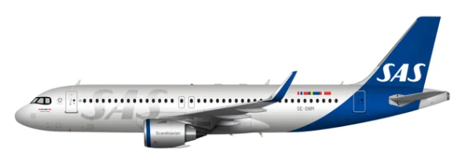
Compartments:
Maximum weights and volumes:
This table shows the maximum weights and volumes per compartment 1, 2, 3, 4 and 5:
Note: NA indicates that volume figure is not given. ACT= Additional Center fuel Tanks
 | Compartment
 | 1 | 2 | 3 | 4 | 5
Weight (kg) | 2202 | 1793 | 1121 | 2064 | 707¹
Combined weight without ACT filled (kg) | 3995² |  | 3892³
Combined weight with ACT filled (kg) | 2849 |  | 1880³
Area load (kg/m²) | 732 | 732 | 732 | 732 | 732
Volume (m³) | 8,91 | 7,28 | 4,76 | 8,54 | 5,92
1: If compartments 3+4 are not filled to at least 75% volume, the maximum weight in CPT 5 is limited to 250 kg
2: Whenever the forward ACT tank is used, the “Combined weight with ACT filled” shall be used
3: To utilize maximum combined weight, when ACT tanks are used, use the below table
Fuel in aft ACT tanks (Kg)¹ | Combined Weight Limit (Kg) CPT 3+4+5
3000 | 3892
3500 | 3392
4000 | 2892
4500 | 2392
5000 | 1880
1: If there is less than 3000 kg of fuel planned in the aft ACT tanks, there may be 3892 kg combined load in CPT 3+4+5

Maximum dimension tables:
Compartments 1 and 2.

These tables show the maximum dimensions of cargo items in compartments 1 and 2. All measurements in cm.

The dimensions are approximate values and refer to rectangular packages.
Upright Loading.
Upright loading refers to large or heavy packages loaded with the assistance of mechanical ground support equipment and maneuvered through the door in an upright position.
Load Limitation on single items when operating to and from the USA
L/W/H: 150 cm / 60 cm / 114 cm. Max weight: 50 kgs
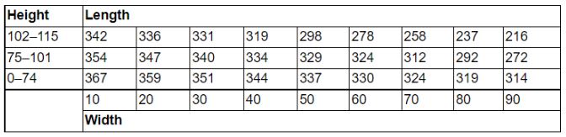
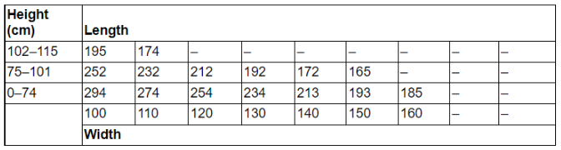
Note: The measurements in the above tables are based on that all the mandatory nets are raised. In case of the need for larger objects to be booked, STOOG needs to give an approval, before the booking is allowed.
Air conditioning system:
The lower compartments are incorporated in the same pressure system as the passenger cabin. But they are not ventilated or heated. They are therefore not suited for transportation of live animals..
Restrictions
There is embargo on AVI (other than AVC and AVF), DG (ICE excluded) and HEA on the A321NX
-----------
Load Limitation on single items when operating to and from the USA
L/W/H: 150 cm / 60 cm / 114 cm. Max weight: 50 kgs

Dangerous Goods
Note: Dangerous goods may not be loaded in the aft hold of the A321NX due to the close proximity of the center fuel tanks.
Dry Ice: Maximum amount in Compartment.
Maximum amount of ICE per compartment
Combined weight
A/C version | Maximum amount  of ICE per A/C | 1 | 1 + 2 | 4 + 5 | 3 + 4 + 5
A321NX | 50 kg | 0 | 50 kg | 0 | 0
Note: Not to be loaded in the same hold as Live Animals (AVI) (AVF-Aquatics and live fish can be loaded in the same hold as ICE).
Radioactive Materials: Maximum Transport Index (TI)
 |  | Max TI pr. Compartment
A/C version | Max TI pr. aircraft | Max TI pr. package  (or Group of packages) | 1 | 2 | 3 | 4 | 5
A321NX | 0 | See note and table below | 0 | 0 | 0 | 0 | 0
Note 1: If the need would arise to transport radioactives on an A321NX, for example on a special charter flight, a permission may be granted by STOOG.
Radioactive Materials: Maximum Package/Group Height and Separation Distance
If the need would arise to transport radioactives on an A321NX, for example on a special charter flight, a permission may be granted by STOOG.
Heavy
There is an embargo on heavy items (80 kg and above), high density- and penetrating-objects in compartments 3, 4 and 5, due to the position of the additional center fuel tanks (ACT). These fuel tanks are protruding into the aft hold and are sensitive to penetration and damage.
There are no such restrictions in the forward hold. In the forward hold, the requirements are the same as for the A320.
Human Remains
No aircraft restrictions other than maximum dimensions, area load and maximum load in hold, but always check SIRIUS for current restrictions on origin, destination and possible embargoes.
Live Animals
SAS has two animal codes that differ from the IATA standard.
AVC – Crustaceans
AVF - Aquatics and live fish
Note: Crustaceans, aquatics and live fish can be secured by volumetrically filling the compartment. AVC and AVF can be loaded together with EAT, AVF can be loaded together with ICE.
Most live animal shipments must be treated as wet cargo. Therefore, plastic sheeting or tarpaulin must be placed under live animal containers in order to avoid soilage of aircraft holds, ULD’s and other load
Isolation from Cold Transfer Beneath Animal Cages
Loaded animal cages need to be insulated from cold transfer, as the aircraft does not have heated floors in the cargo compartments. Insulation can be made by various methods, such as: Spreader boards under the cage; insulating material, blankets etc.
Note: If the insulating material also can absorb fluids, the LAR requirement to have plastic under the boxes or cages can be ignored.

 |  | Maximum qty in compartment (kg)
Group | Animal, Example | 1 | 3 + 4 + 5
1 | Tropical fish, fish | No limit | No limit
2 | Shrimps, reptiles, snakes, crabs, frogs, oysters | No limit | No limit
3 | Cats, dogs, other pets | Not allowed
4 | Other animals | 0 | 0
Live Human Organs
Live Human Organs (LHO) shall be loaded close to the cargo door. STOOG, in coordination with STOOF and STOG3, may grant an exception to stow LHO in cabin.
Perishables
No aircraft restrictions other than maximum dimensions, area load and maximum load in hold, but always check SIRIUS for current restrictions on origin, destination and possible embargoes.
Sensitive
No aircraft restrictions other than maximum dimensions, area load and maximum load in hold, but always check SIRIUS for current restrictions on origin, destination and possible embargoes.

Valuable
No aircraft restrictions other than maximum dimensions, area load and maximum load in hold, but always check SIRIUS for current restrictions on origin, destination and possible embargoes.
Vulnerable
No aircraft restrictions other than maximum dimensions, area load and maximum load in hold, but always check SIRIUS for current restrictions on origin, destination and possible embargoes.

Document info:
Author: | Approved by: | Effective date:
Michael Beck, CPHFD | Michael Beck, CPHFD | 01JUN2021
Document review date: | Document review by: | Department:
15FEB2023 | Michael Beck, CPHFD | CPHFD
SCM Document: | sascargo.com: | Live Document:
Yes | Yes | Yes

