A319
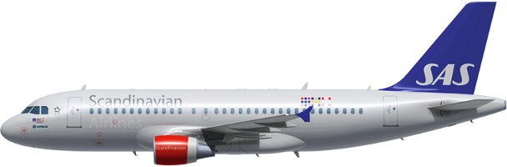

Compartments:
Maximum weights and volumes:
This table shows the maximum weights and volumes per compartment 1, 4 and 5:
Note: NA indicates that volume figure is not given.
 | Compartments
 | 1 | 4 | 5
Weight (kg) | 2268 | 2988 | 1399
Combined weight (kg) | 2268 | 4387
Area load (kg/m²) | 732 | 732 | 732
Volume (m³) | 8,51 | 11,83 | 7,22

Maximum dimension tabels:
Compartment 1
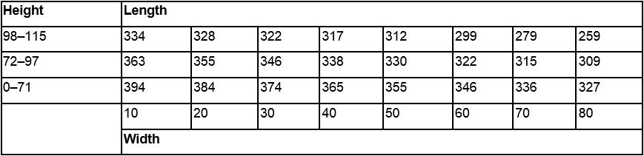
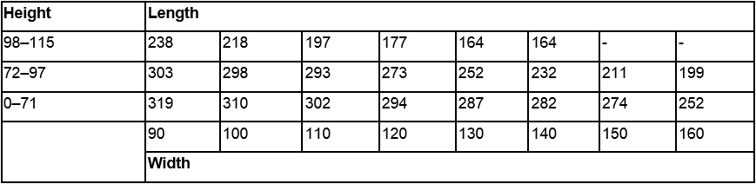
Compartment 4
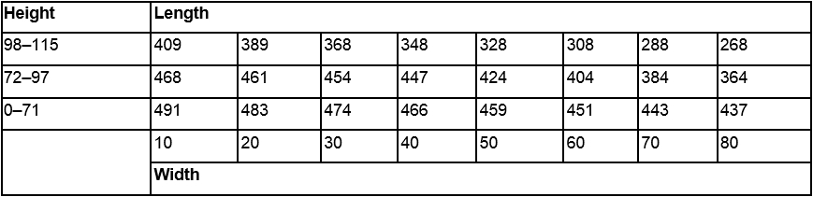
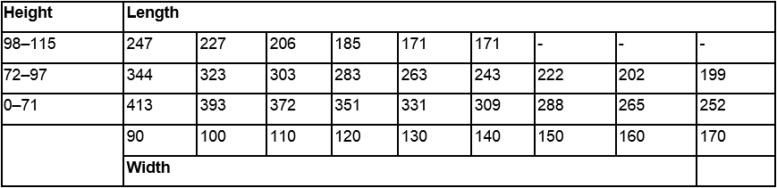
Compartment 5
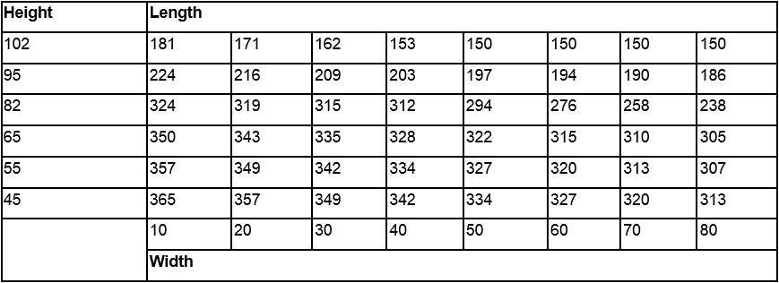
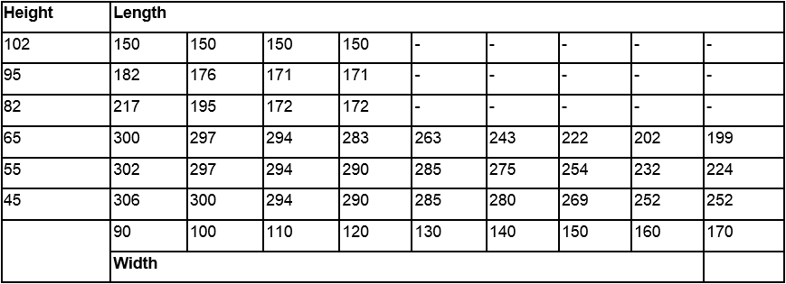

Air conditioning system:
The lower compartments are incorporated in the same pressure system as the passenger cabin and are ventilated and heated only to a certain extent for transportation of live animals.
Restrictions:
Dangerous Goods
Dry Ice: Maximum amount in Compartment.
Maximum amount of ICE per compartment
Combined weight
 | Max weight per A/C | 1 | 4+5
A319 | 100 kg | 50 kg | 50 kg
Note: Not to be loaded in the same hold as Live Animals (AVI). (AVF-Aquatics and live fish can be loaded in the same hold as ICE).
Radioactive Materials: Maximum Transport Index (TI)
 |  |  | Max TI pr. Compartment
A/C version | Max TI pr. aircraft | Max TI pr. package  (or Group of packages) | 1 | 2 | 3 | 4 | 5
A319 | 9 | See note and table below | 4 | N/A | N/A | 4 | 1
Note 1: The maximum allowed TI per package (or group of packages), is depending on the height of the package (or group of packages).
Note 2: Packages in compartment 5 may not be higher than 50 cm.
Radioactive Materials: Maximum Package/Group Height and Separation Distance
The below table shows:
- The maximum allowed height per package (or group of packages).
- The minimum separation distance (horizontally) between packages (or groups of packages).
Note: Use the column for Minimum separation distance when:
    - the package/group height, or
    - the Transport Index (TI)
exceeds the permitted values for grouping packages together.

Transport Index  (TI) per package  (or group of  packages) | Max. height per  package (or  group of  packages) (cm) | Min. separetion  distance  horizontally (cm) | Category
0.0 | No restriction | No restriction | I – White (RRW)
0.0–1.0 | 105 | 100 | II – Yellow (RRY)
1.1–2.0 | 85 | 150 | III – Yellow (RRY)
2.1–3.0 | 65 | 210 | III – Yellow (RRY)
3.1–4.0 | 50 | 255 | III – Yellow (RRY)
More than 4.0 | Not allowed | Not allowed | III – Yellow (RRY)
Note: For the separation of packages (or groups of packages with different Transport Indices (TI), the minimum separation distance required for the package (or group of packages) with the higher transport index must be applied.
Heavy
There are no restrictions regarding HEA other than maximum dimensions, area load and maximum load in hold. HEA shall always be secured by means of lashing. Volumetrically filling the compartment will not be sufficient. Always check SIRIUS for current restrictions on origin, destination and possible embargoes
Human Remains
No aircraft restrictions other than maximum dimensions, area load and maximum load in hold, but always check SIRIUS for current restrictions on origin, destination and possible embargoes.
Live Animals

SAS has two animal codes that differ from the IATA standard.

AVC – Crustaceans
AVF - Aquatics and live fish

Note: Crustaceans, aquatics and live fish can be secured by volumetrically filling the compartment. AVC and AVF can be loaded together with EAT, AVF can be loaded together with ICE.

Most live animal shipments must be treated as wet cargo. Therefore, plastic sheeting or tarpaulin must be placed under live animal containers in order to avoid soilage of aircraft holds, ULD’s and other load

Isolation from Cold Transfer Beneath Animal Cages
Loaded animal cages need to be insulated from cold transfer, as the aircraft does not have heated floors in the cargo compartments. Insulation can be made by various methods, such as: Spreader boards under the cage; insulating material, blankets etc.
Note: If the insulating material also can absorb fluids, the LAR requirement to have plastic under the boxes or cages can be ignored.

 |  | Maximum qty in compartment (kg)
Group | Animal, Example | 1 | 4 + 5
1 | Tropical fish, fish | No limit | No limit
2 | Shrimps, reptiles, snakes, crabs, frogs, oysters | No limit | No limit
3 | Cats, dogs, other pets | See note ¹
4 | Other animals | 100 | 100

Note: [1] All AVIH shall be loaded in the aft hold (Compartment 4+5).

Number of Animal Cages | Flight Time:  Less than 4 h | Flight Time:  4 hours and Above
1 | Plan the crate in CPT 5, no other load allowed in CPT 5 | Plan the crate in CPT 5, no other load allowed in CPT 5
2 | Plan one in CPT 5, no other load allowed in CPT 5.  Plan the second crate in CPT 4, net section 41 or 42. No other load allowed in that net section. | Load one in CPT 5, no other load allowed in CPT 5.  Plan the second crate in CPT 4, net section 41 or 42. No other load allowed in that net section.
- For A319, compartment 4+5 is the same hold, therefore AVI cannot be loaded in Cpt 5 if there is ICE in Cpt 4 or 5.
Live Human Organs
Live Human Organs (LHO) shall be loaded close to the cargo door.
Restriction: Separate from Radioactive materials by at least 0,5 meters.
Note: LHO may be loaded in the cabin with the commander’s approval
Perishables
No aircraft restrictions other than maximum dimensions, area load and maximum load in hold, but always check SIRIUS for current restrictions on origin, destination and possible embargoes.
Sensitive
No aircraft restrictions other than maximum dimensions, area load and maximum load in hold, but always check SIRIUS for current restrictions on origin, destination and possible embargoes.

Valuable
No aircraft restrictions other than maximum dimensions, area load and maximum load in hold, but always check SIRIUS for current restrictions on origin, destination and possible embargoes.
Vulnerable
No aircraft restrictions other than maximum dimensions, area load and maximum load in hold, but always check SIRIUS for current restrictions on origin, destination and possible embargoes.
Document info:
Author: | Approved by: | Effective date:
Michael Beck, CPHFD | Michael Beck, CPHFD | 01MAR2021
Document review date: | Document review by: | Department:
15FEB2023 | Michael Beck, CPHFD | CPHFD
SCM Document: | sascargo.com: | Live Document:
Yes | Yes | Yes

