A220-300

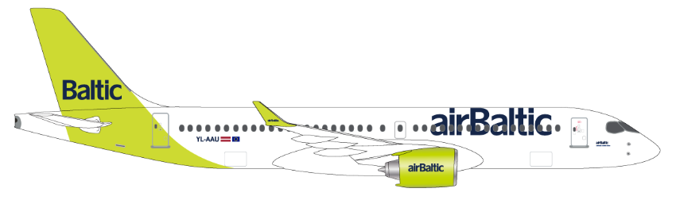

Compartments:

Maximum weights and volumes:

This table shows the maximum weights and volumes per compartment 1, 2, 3 and 4:
Note: NA indicates that volume figure is not given.

Valid for Version A220-300

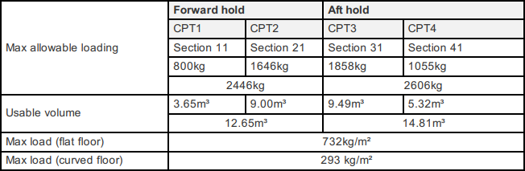

Caution: The total load of each compartment must not exceed the maximum allowed for the hold.
This is a diagram of compartments 1 and 2 (Forward hold):

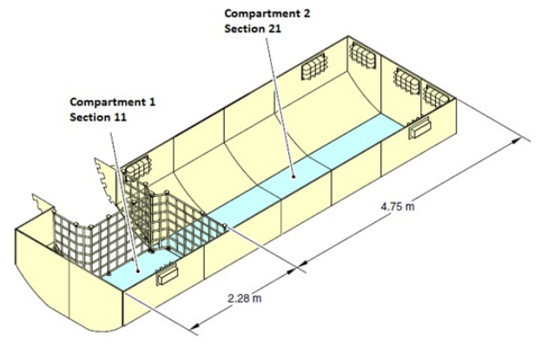

This is a diagram of compartments 3 and 4 (AFT hold):

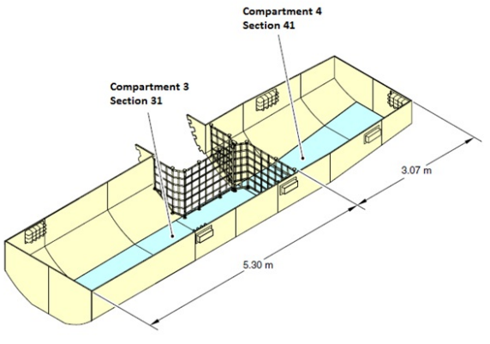

Maximum dimension tables:

Compartment 1 and 2

These tables show the maximum dimensions of cargo items in compartment 1 and 2. All measurements in cm.

CAUTION: If the package is loaded in compartment 1, the maximum length is limited to 178 cm.
CAUTION: For a package wider than 84 cm must be supported on planks and lashed.

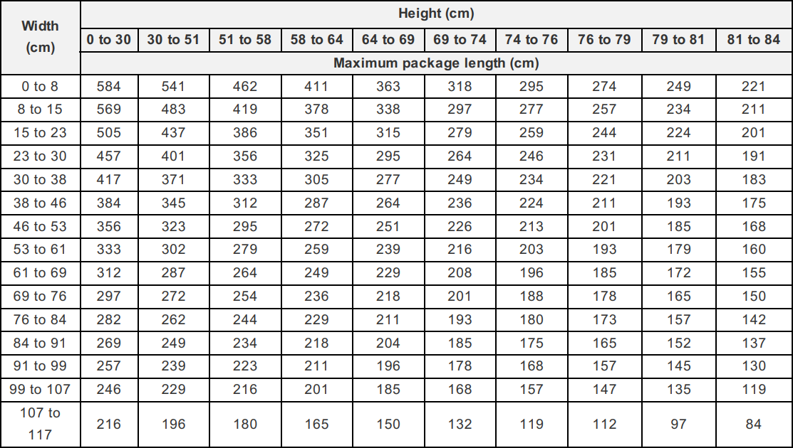

Compartment 3
CAUTION: For a package wider than 84 cm must be supported on planks and lashed.
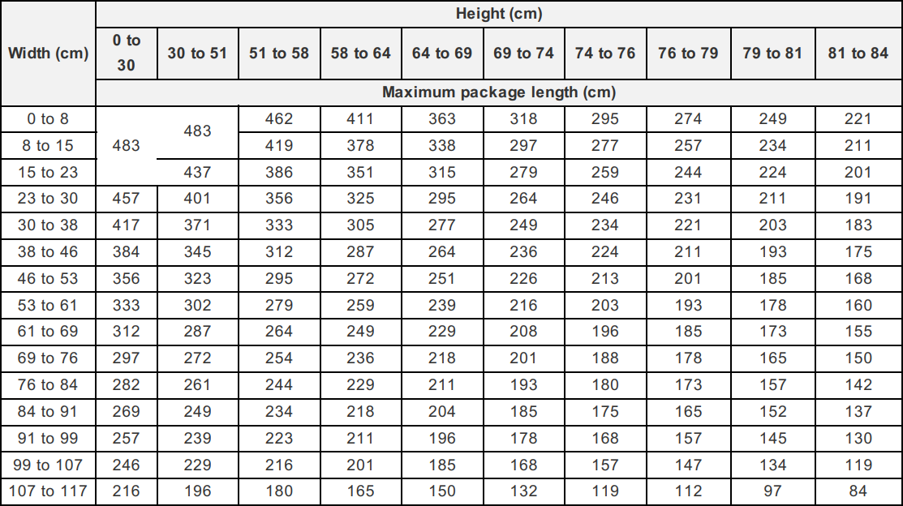
Compartment 4
CAUTION: For a package wider than 84 cm must be supported on planks and lashed.
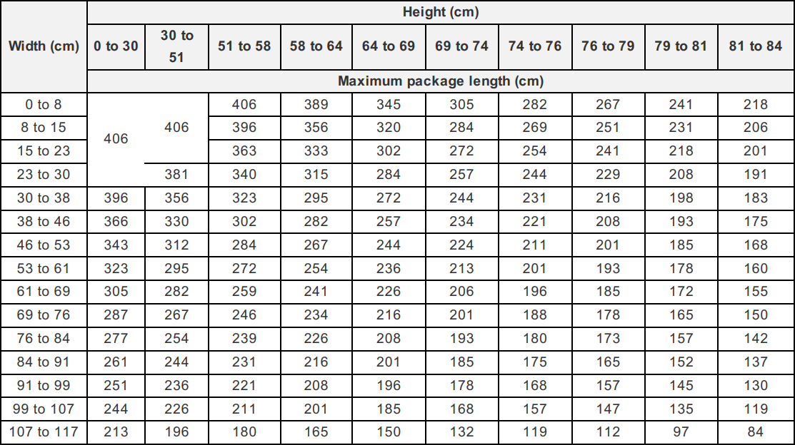

Air conditioning system:
Compartments 1 and 2:
Ventilation and heating are available. Standard configuration will be VENT ON and HEAT OFF. The ventilation system supplies the airflow to a maintained temperature above 4°C in the forward hold. Heating settings in case of temperature sensitive load will be adjusted by flight crew based on the NOTOC.
Both compartments are equipped with lights and incorporated in the pressurization system.
Compartments 3 and 4:
Only ventilation is available. Standard configuration will be VENT ON. The ventilation system supplies the airflow to a maintained temperature above 2°C in the aft hold.
Both compartments are equipped with lights and incorporated in the pressurization system.

Restrictions
Dangerous Goods
Dry Ice: Maximum amount in Compartment.
Maximum amount of ICE per compartment
Combined weight
A/C version | Maximum amount  of ICE per A/C | 1 + 2 | 3 + 4
A220 | 908 kg | 454 kg | 454 kg
Note: Dry ice may normally not be loaded together with AVI, AVC and AVP. However, Live tropical Fish (AVF) and other fish for aquarium use may be loaded together with ICE, as they are packed in closed containers and are not dependent on the oxygen in the compartment.
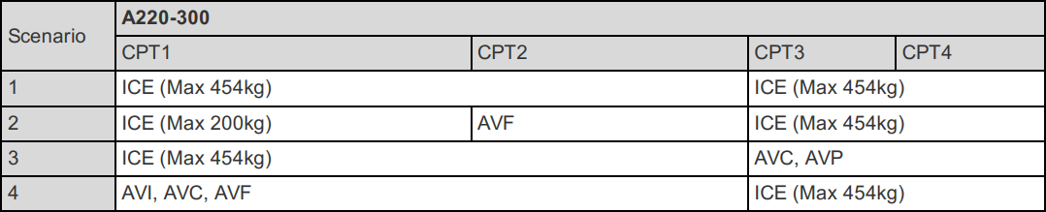

Radioactive Materials: Maximum Transport Index (TI)
 |  |  | Max TI pr. Compartment
A/C version | Max TI pr. aircraft | Max TI pr. package  (or Group of packages) | 1 | 2 | 3 | 4
A220 | 4 | See note and table below | 0 | 0 | 4 | 0
Radioactive Materials: Maximum Package/Group Height and Separation Distance
The below table shows:
    - The maximum allowed height per package (or group of packages).
    - The minimum separation distance (horizontally) between packages (or groups of packages).
Note: Use the column for Minimum separation distance when:
- the package/group height, or
- the Transport Index (TI)
exceeds the permitted values for grouping packages together.
Transport Index  (TI) per package  (or group of  packages) | Max. height per  package (or  group of  packages) (cm) | Min. separetion  distance  horizontally (cm) | Category
0.0 | No restriction | No restriction | I – White (RRW)
0.0–1.0 | n/a | 30 | II – Yellow (RRY)
1.1–2.0 | n/a | 50 | III – Yellow (RRY)
2.1–3.0 | n/a | 70 | III – Yellow (RRY)
3.1–4.0 | n/a | 85 | III – Yellow (RRY)
More than 4.0 | Not allowed | Not allowed | III – Yellow (RRY)
Note: For the separation of packages (or groups of packages with different Transport Indices (TI), the minimum separation distance required for the package (or group of packages) with the higher transport index must be applied.
Heavy
There are no restrictions regarding HEA other than maximum dimensions, area load and maximum load in hold. HEA shall always be secured by means of lashing. Volumetrically filling the compartment will not be sufficient.
Always check SIRIUS for current restrictions on origin, destination and possible embargoes.
Human Remains
Do not put non-cremated human remains (HUM) in the same compartment as live animals (AVI), perishables/foodstuffs (EAT) and live human organs (LHO).
If a coffin containing HUM weighs 150 kg or more, it shall also be regarded as a heavy item (HEA) for loading purposes.
Human remains (HUM) shall be lashed, even if the compartment or net section is volumetrically full.
Note: HUM shall always be used as remark code on Loading instruction, Loadsheet and LDM, irrespective of weight
Live Animals

Live tropical fish and other fish for aquarium use may be loaded together with ICE, as they are packed in closed containers and do not depend on oxygen in compartment.

Animals that are natural enemies must not be loaded together in the same compartment.

Animals known to be for laboratory use must not be loaded together with other animals, in order to reduce risk of cross-infection or contamination.

A Notification to Captain (NOTOC) shall be issued when live animals are loaded in aircraft cargo compartment.

Radioactive materials of Category II-Yellow and Category III-Yellow packages, overpacks and freight containers must be separated from live animals by a distance of 0.5 m or more for journeys of 24 hours or less, for journeys of more than 24 hours containers must be separated by a distance of 1.0 m or more.
Note: Crustaceans, aquatics and live fish can be secured by volumetrically filling the compartment. AVC and AVF can be loaded together with EAT, AVF can be loaded together with ICE.

Most live animal shipments must be treated as wet cargo. Therefore, plastic sheeting or tarpaulin must be placed under live animal containers in order to avoid soilage of aircraft holds, ULD’s and other load.

Isolation from Cold Transfer Beneath Animal Cages
Loaded animal cages need to be insulated from cold transfer, as the aircraft does not have heated floors in the cargo compartments. Insulation can be made by various methods, such as: Spreader boards under the cage; insulating material, blankets etc.
Note: If the insulating material also can absorb fluids, the LAR requirement to have plastic under the boxes or cages can be ignored.

Table on the next pages shows the quantity limits for loading live animals on A220-300 aircraft.
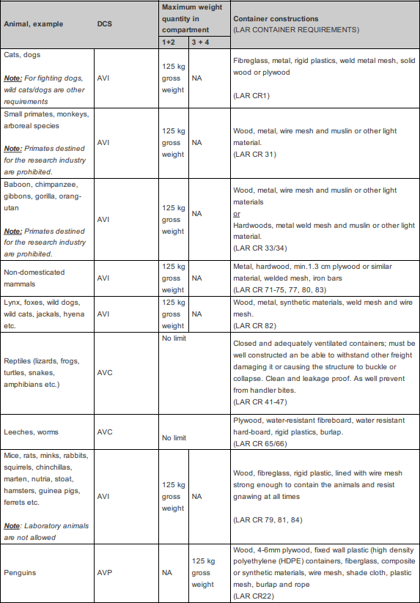

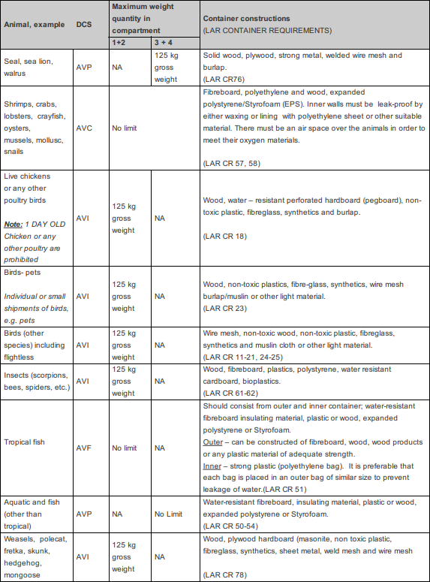

Live Human Organs
Live organs shall be loaded as close as possible to the door section. Do not load LHO together with Live animals
Perishables
No aircraft restrictions other than maximum dimensions, area load and maximum load in hold, but always check SIRIUS for current restrictions on origin, destination and possible embargoes.
Sensitive
No aircraft restrictions other than maximum dimensions, area load and maximum load in hold, but always check SIRIUS for current restrictions on origin, destination and possible embargoes.
Valuable
No aircraft restrictions other than maximum dimensions, area load and maximum load in hold, but always check SIRIUS for current restrictions on origin, destination and possible embargoes.
VAL shall not be reported separately on the Loading Report. The weight is included in the general cargo figure.
Vulnerable
No aircraft restrictions other than maximum dimensions, area load and maximum load in hold, but always check SIRIUS for current restrictions on origin, destination and possible embargoes.

Document info:
Author: | Approved by: | Effective date:
Michael Beck, CPHFD | Michael Beck, CPHFD | 12MAY2022
Document review date: | Document review by: | Department:
15FEB2023 | Michael Beck, CPHFD | CPHFD
SCM Document: | sascargo.com: | Live Document:
Yes | Yes | Yes

